

**Introduction**:

Welcome to the ultimate *docker* course.

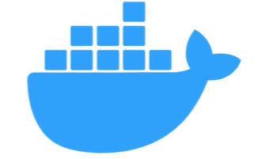

We will learn everything we need to know about docker from the basics to more advanced concepts.

We will start off with a really simple project to understand the basics then we will use docker to run and deploy a full stack application.

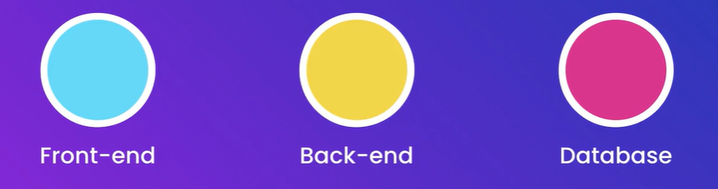

So we learn all the necessary techniques and apply them to any project.

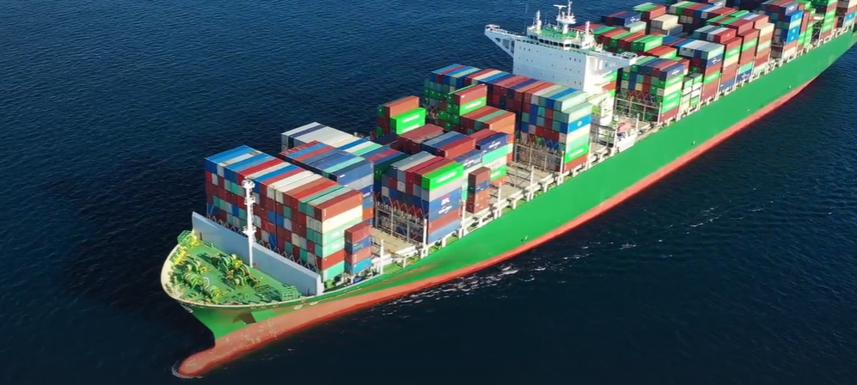

**Prerequisites**:

Don’t need any prior knowledge of docker. But we will need,



At least worked on frontend, backend in terms of programming experience.

**Introduction to Section**:

In this section we will learn what docker is and why its popular and then…

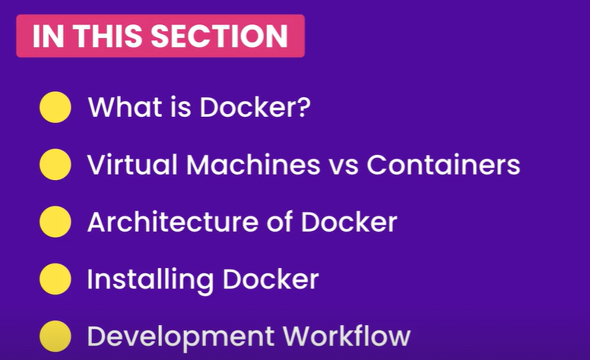

**What is Docker**:

A Docker is…



**“***It is a platform for building, running and shipping applications in a consistent manner. So if our application works on the development machine, it can run and function the same way on other machines***”**

There are three reasons why this happens…

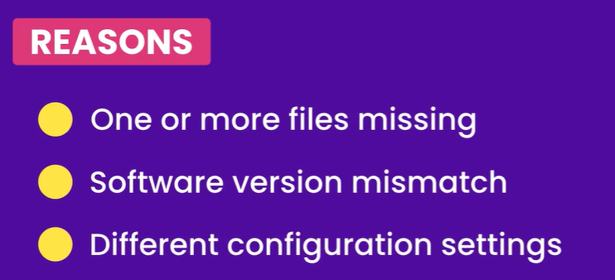

*In other words*,

🡪 If one or more files are not included as part of the deployment. App is still missing something.

🡪 If the target machine is running a different software version then what our application needs. For example our application runs on node version 14 but target machine has node version 9.

🡪 Configuration settings or environment variables are different across these machines.

This is where docker comes to the rescue,

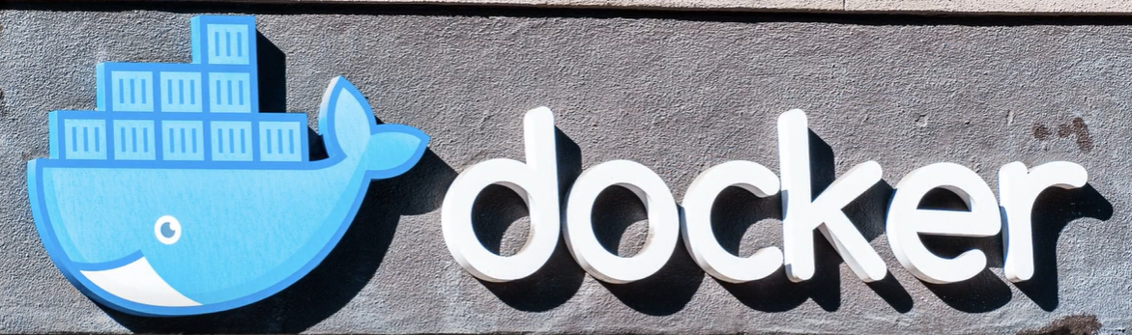

*With docker we can easily package our application with everything it needs and run it anywhere on any machine with docker*.

So if our application needs a given version of node and MongoDB, all of these will be included in our applications package.

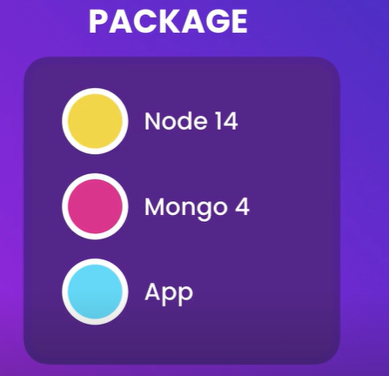

Now *we can take this package and run it on any machine that runs docker, so if it works on our development machine, it’s definitely going to work on our test and production machines*.

There is one more benefit…

If someone new joins our team, they do not have to spend half a day or so setting up a new machine to run our application. *They do not have to install and configure all the dependencies*.



*They simply tell Docker to bring up our application and Docker itself will automatically download and run these dependencies inside an isolated environment called a* ***container***.

That is the beauty of *Docker*.

This isolated environment allows multiple applications use different versions of same software side by side. So one application may use node version 14 and another application might use version 9.

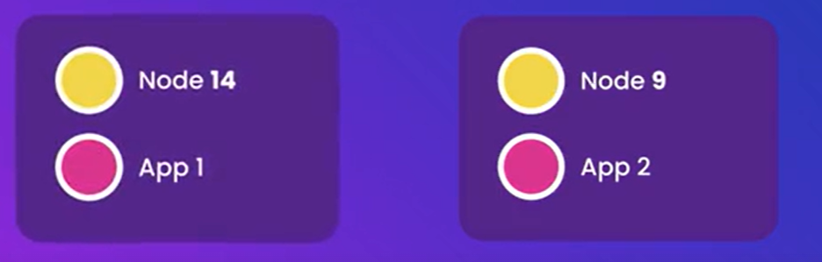

Both applications can run side by side on the same machine without messing with each other. So this is how docker allows us to consistently run an application on different machines.

*There is one more benefit*…

*When we are done with one of the applications and do not want to work on it anymore. We can remove the application and all its dependencies in one go*.

Without docker, as we work on different projects our development machine gets cluttered with so many libraries and tools that are used by different applications.



With docker we do not have to worry about this, because each application runs with its dependencies inside an isolated environment and *we can safely remove all its dependencies to clean up our machine without worrying about messing up some other app’s code*.

In a nutshell docker helps us to,



And that’s why a lot of employers are looking for people with docker skills.

**Virtual Machines Vs Containers**:

In the previous lesson we briefly talked about containers.

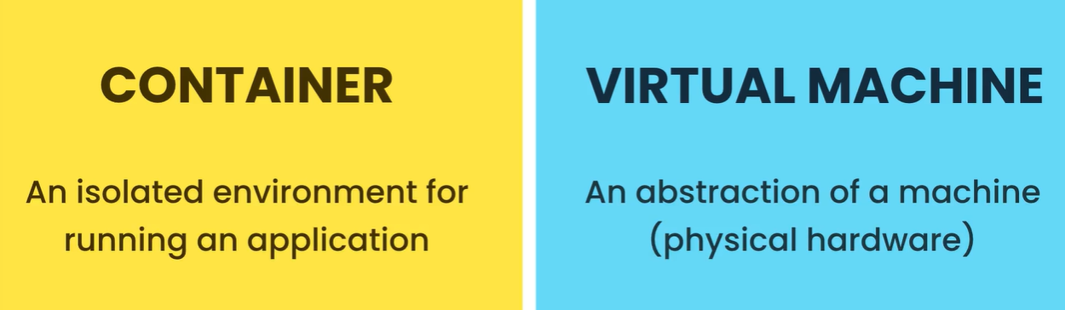

A container is an isolated environment for running an application. One of the common questions asked is how a container is different from virtual machines or VMs.

A virtual machine as the name implies is an abstraction of a machine or physical hardware. So we can run several virtual machines on a real physical machine. For example,

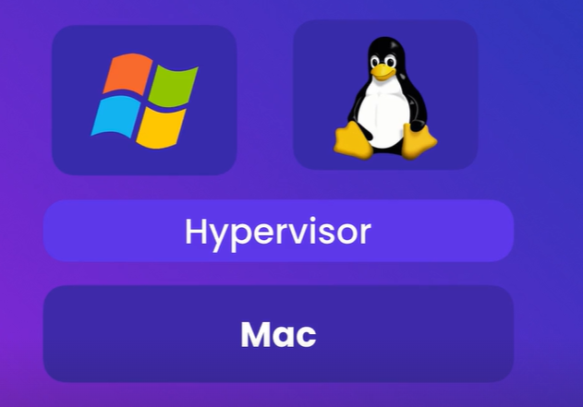

On a Mac we can run two virtual machines, one with windows and other is with Linux. To do that, we use a tool called *Hypervisor*.

“*A hypervisor is a software we use to create and manage virtual machines*.” There are many hypervisors available like…

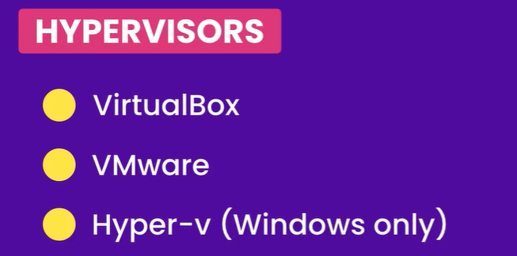

We can run two different applications inside two separate virtual machines that we created in our local machine.

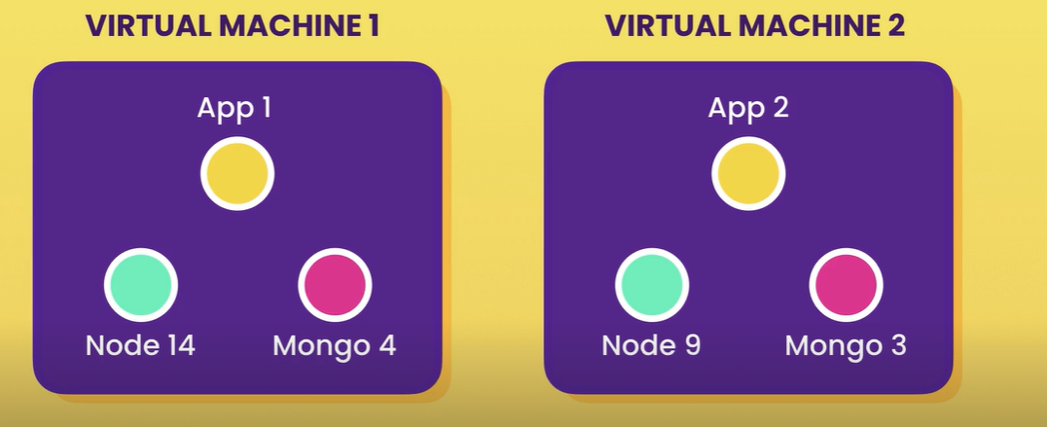

But there are few problems with virtual machines,

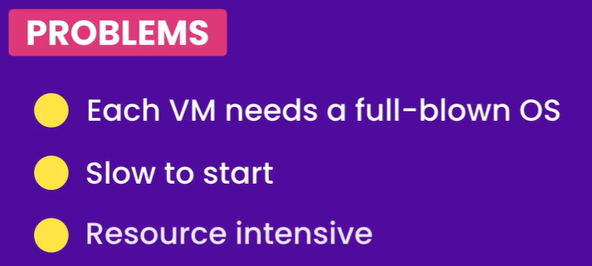

But let us see how containers overcome problems with virtual machines, since they provide same type of isolation.

*Benefits of containers*:

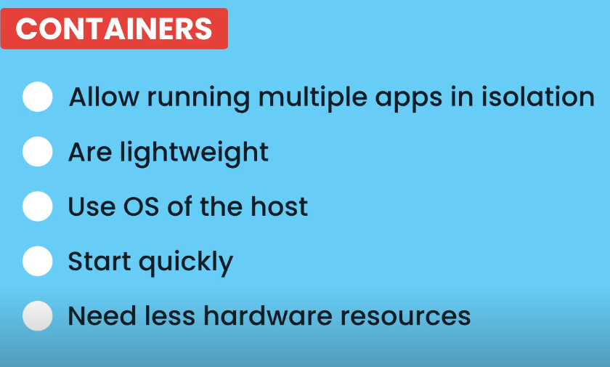

**Docker Architecture**:

Docker uses a client – server architecture. So it has a client component that talks to a server component using RESTful API.

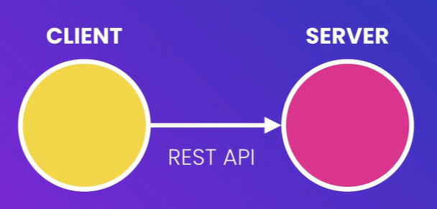

The server also called *Docker Engine*, sits in the background and *takes care of building and running Docker containers*.

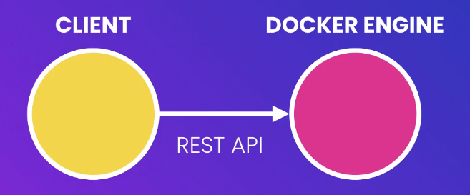

***A container is just a process***, like other processes running on your computer. But it is a special kind of process which we will talk about soon.

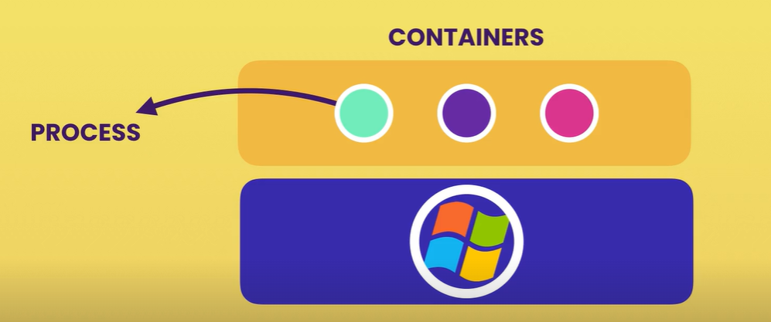

As we know unlike virtual machines, containers don’t contain a full blown OS. *Instead all containers on a host share the operating system of the host or more accurately* ***all containers share the kernel of the host***.



A *kernel* is the core of an operating system. Its like engine of a car or the part that manages all applications as well as hardware resources like memory and CPU.

*Every operating system has its own kernel or engine and these* ***kernels have different APIs****. That is why we cannot run a windows application on a Linux because under the hood, this* ***application needs to talk to the kernel of the underlying operating system***.

In other words, that means on Linux machine we can only run Linux containers because these containers need to Linux. On a windows machine however we can run both windows and Linux containers (*windows 10 is shipped with custom built Linux kernel*).

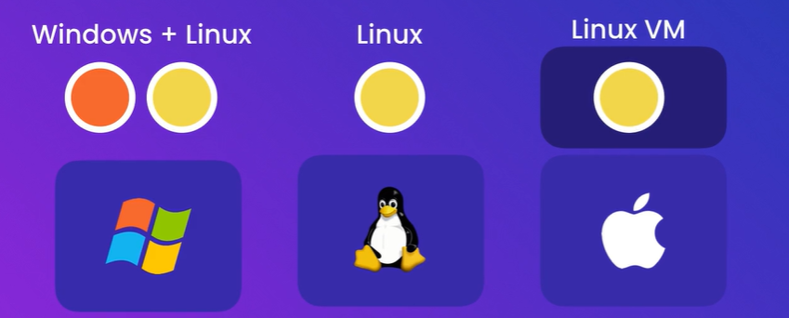

MacOS has its own kernel which is different from Linux and windows kernels and this kernel does not have native support for containerized applications. So docker on mac uses a lightweight Linux virtual machine to run Linux containers.

**Installing Docker**:

Download docker from their official site

[Install Docker Desktop on Windows | Docker Docs](https://docs.docker.com/desktop/install/windows-install/)

After installation, pc will restart.

Then check installation successful or not using docker version.

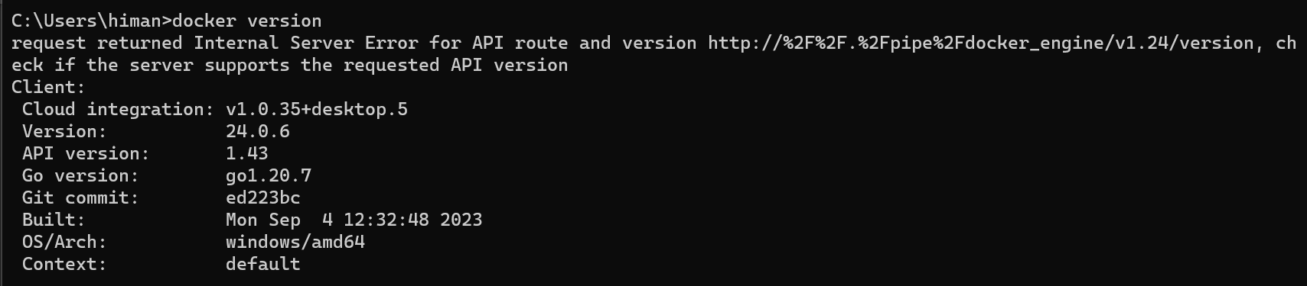

Installation is successful but our docker engine is not running,

error during connect: this error may indicate that the docker daemon is not running: Get "http://%2F%2F.%2Fpipe%2Fdocker_engine/v1.24/version": open //./pipe/docker_engine: The system cannot find the file specified.

Need to start docker server to do that and some troubleshooting.

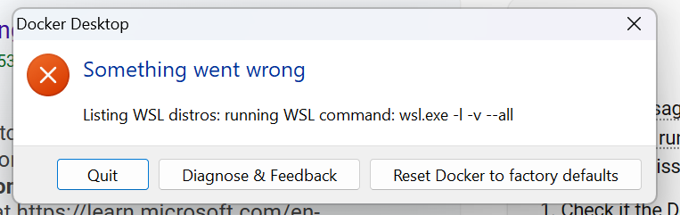

Since I am getting this error.

I tried installing wsl separately on my windows 11 machine, using wsl --install command with admin permission.

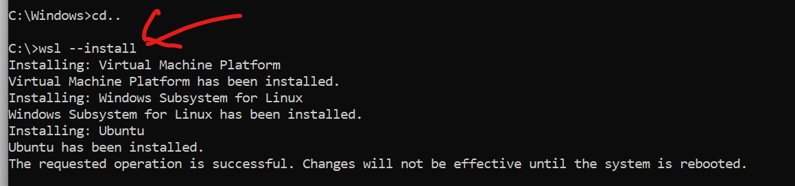

Go to

[How to install Windows Subsystem for Linux (WSL) on Windows 11 - Pureinfotech](https://pureinfotech.com/install-wsl-windows-11/)

For installation of wsl on windows.

Now I restart it and check the docker app.

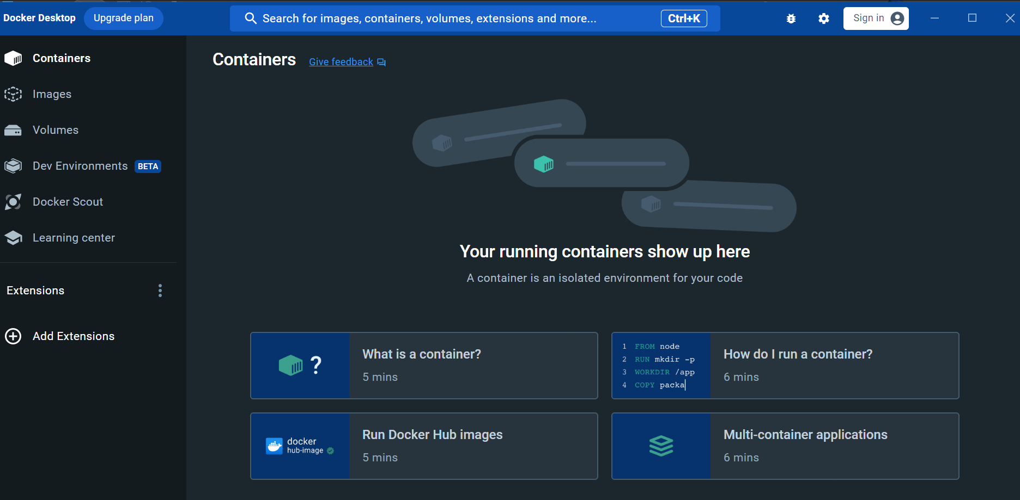

I can see the docker panel now.

And If I check docker version, we can see complete docker info.

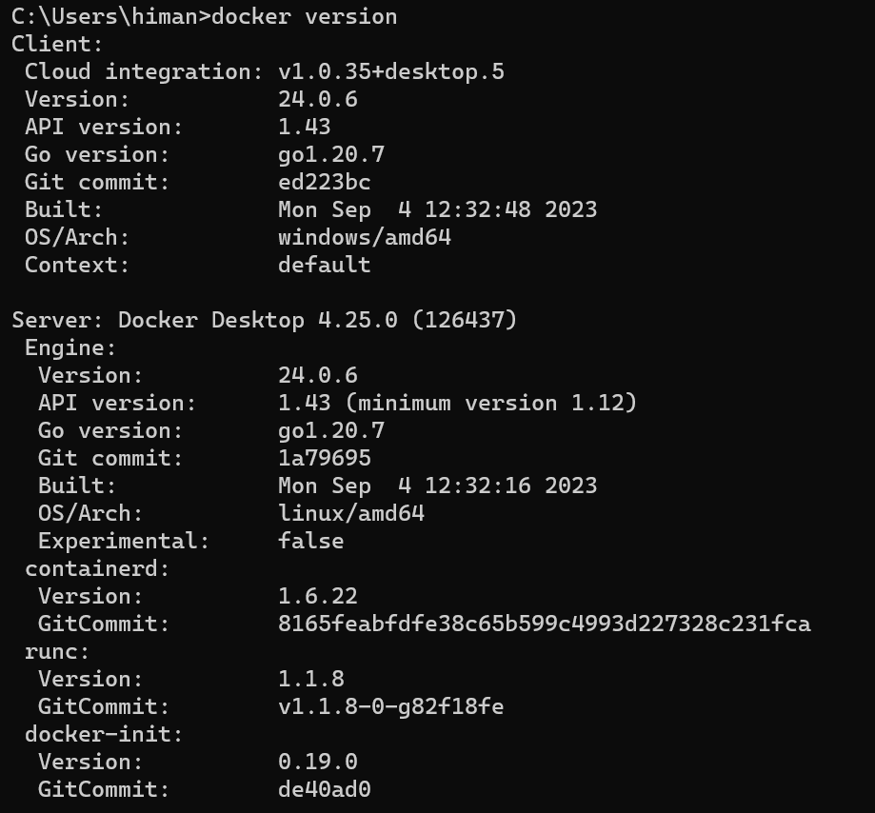

We would not see the server information here if the docker server is not currently running.

This setting of using *WSL2 based engine* is force checked in my Docker general settings.



Below is a brief intro about wsl2:

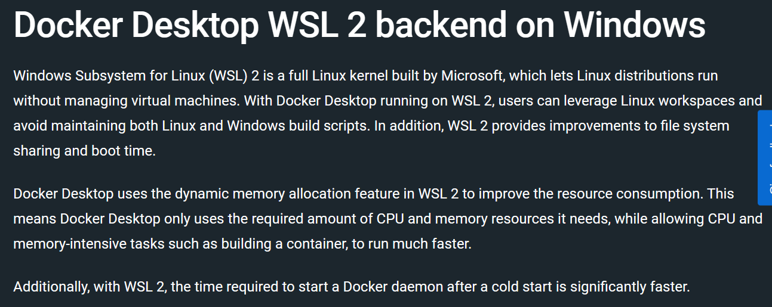

**Development Workflow**:

To start off, we take an application. It does not matter what kind of application it is or how its built, we just take it and *dockerize* it (*means make a small change in it so that it be run by docker*). How?

Just add a *Docker file* to the application.

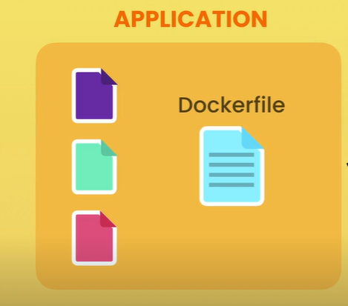

*A docker file is a plain text file that includes instructions that docker uses to package up this application into an image*.

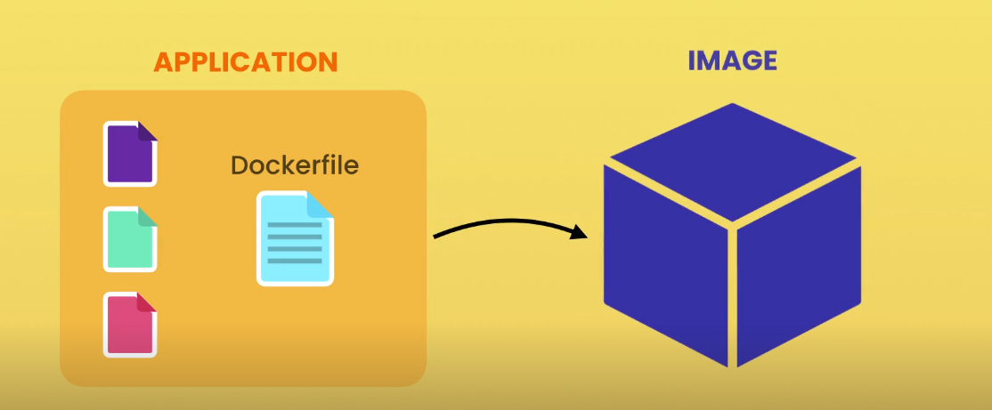

This image contains everything our application needs to run which typically includes these things.

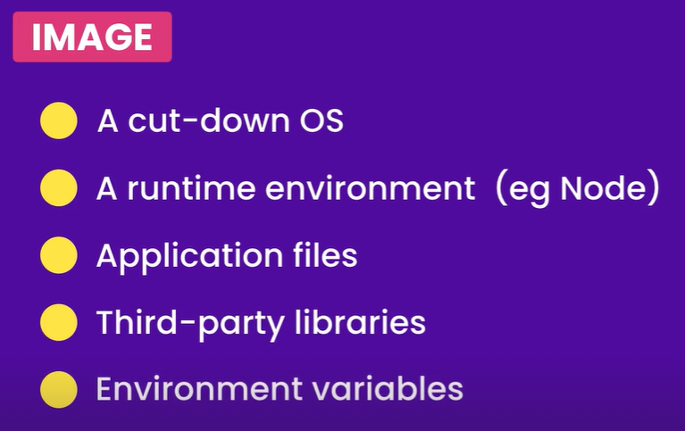 And so on…

So we create a docker file and give it to docker for packaging our application into an image.

*Once we have an image we tell docker to start a container using that image*. So a container as we know is a process. But it is a special kind of process (*because it has its own file system which is provided by the image*).

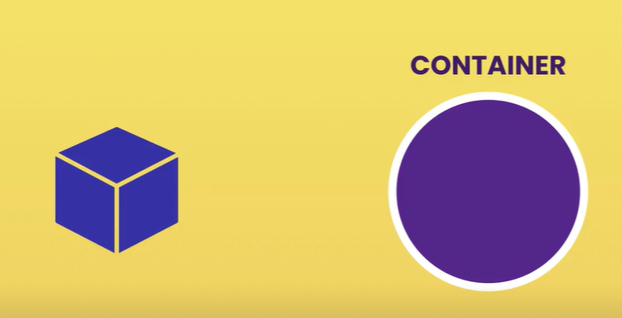

So our application gets loaded inside a container or a process and this is how we run our application locally on our development machine.

*Instead of directly launching the application and running it inside a typical process,* ***we tell docker to run it inside a container, an isolated environment***.

Now here is the beauty of docker, once we have this image we can push it to docker registry like docker hub (*docker hub to docker is like git hub to git*) which is a storage for docker images that anyone can use.

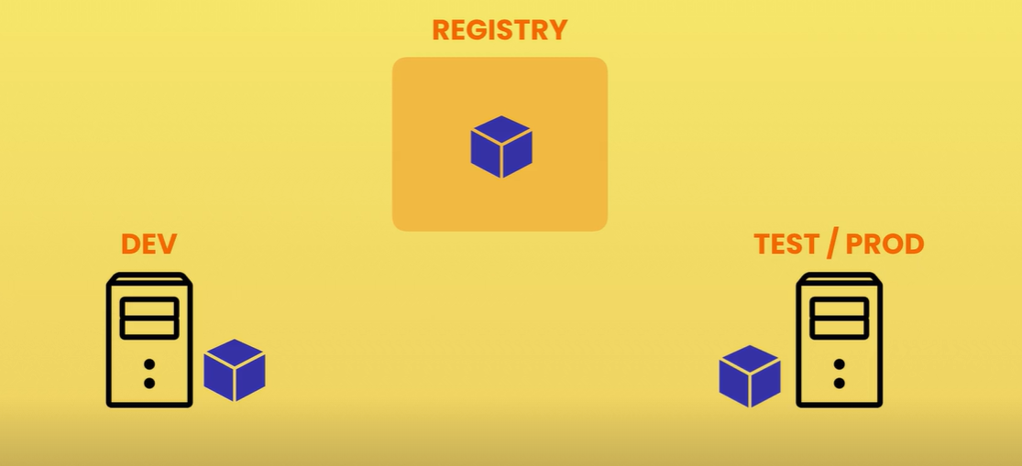

Once our application images is on docker hub then we can put it on any machines running docker.

*The TEST/PROD machine has the same image we have on our DEV machine which contains a specific version of our application with everything it needs*.

So *we can start our application the same way we start in our development machine,* ***just tell docker to start a container using this image***.

With Docker we no longer need to maintain long complex release documents that have to be precisely followed. *All the instructions for building an application are written in the docker file*. With that we can package our application into an image and run it virtually anywhere.

*On a Side note*:

After installation, run docker run hello-world command

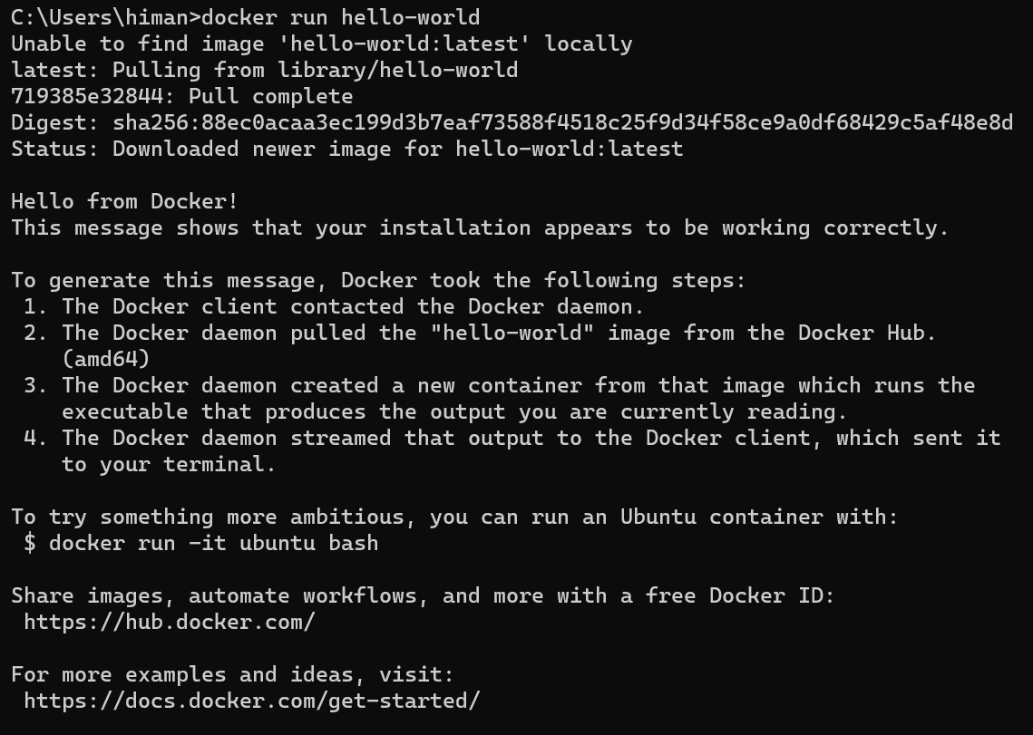

**Docker in Action**;

In this lesson we will walk through a typical development workflow just to see the big picture. All the steps we see here are going to be covered in depth later in the course.

1. Create a new directory in desktop called *hello-docker* and a app.js file where we will simply write a console.log statement.

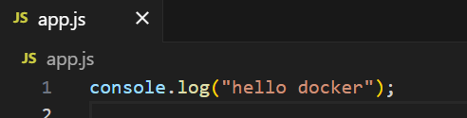

Let us say this is an application and we want to dockerize this app. So *we want to build, run and ship it using docker*.

Typically without docker, if we want to ship this application or more accurately this program to a different computer. Then on that computer we need to install node and then go to that computer and write node app.js.



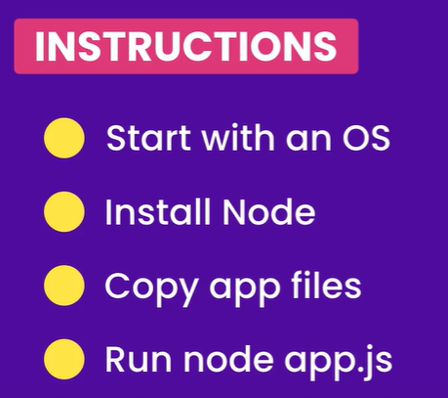🡨 Typical instructions for deploying this program.

What if we were working with really complex application, we would end up with a complex release document that has to be precisely followed.

This is where *docker* comes to the rescue, we can write these instructions inside a ***Dockerfile*** and let docker package our application.

1. Create a *Dockerfile* in folder.

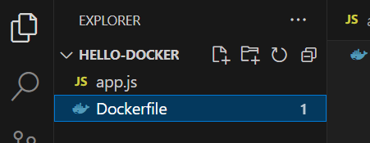🡨

This Dockerfile does not have any extensions.

Note: If using VS code, install necessary extensions for Docker.

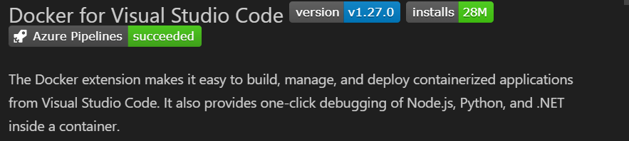

Back to the Dockerfile, here we can write instructions for packaging our application.

🡪 Typically we start from a *base image*. This base image has a bunch of files which we will take and add additional files to it.

(*like inheritance in programming*)

FROM linux

Or

FROM node

A base image here is a Linux image and then install node on top of it or we can start from a node image (*this image is already built on top of Linux*).

***HOW DO WE KNOW THESE IMAGE NAMES****?*

Well these images gets officially published on docker hub.

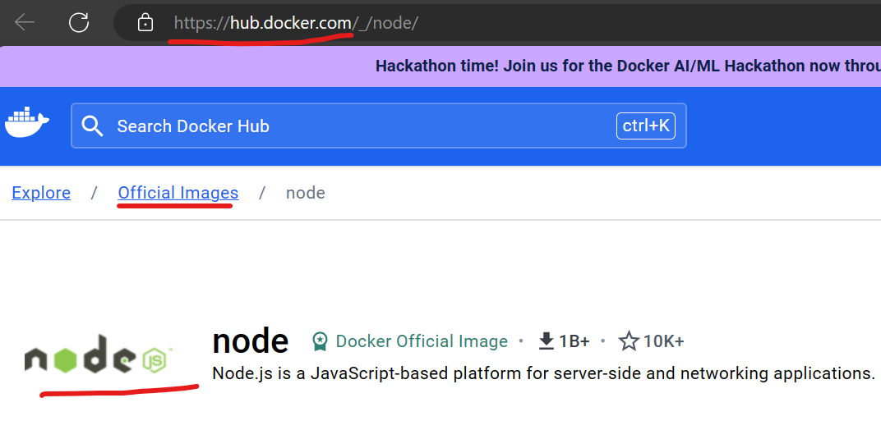

If we go to hub.docker.com and search for node, we can see official node image here. So *docker hub is a registry for docker images*.

So in the Dockerfile we start from a node image,

FROM node

But if we look at docker hub we can see there are multiple node images. These node images are built on different distributions of linux.

So *linux has different distributions or Flavors used for different purposes*.

Here we can *specify a tag using a colon* to specify which linux distribution we want to use.

FROM node:alpine

For this demo we will use *alpine* because it’s a very small linux distribution (*size of image we download and build on top of is going to be very small*).

1. Now we will *copy our application or program files*. For that we are going to use *COPY* instruction or COPY command where *we copy all our files and the current directory into the app directory of this image*.

FROM node:alpine

COPY . /app 🡪 *Here*

So the image has a file system where we create a directory called *app*.

1. Finally we are going to use CMD (*or command*) instruction to execute a command.

FROM node:alpine

COPY . /app

CMD node /app/app.js 🡪 *Here*

Here app.js file is inside *app* directory here therefore we mention ./app/app.js.

Alternatively we could *set current working directory* to /app then we do not need to prefix it in CMD.

FROM node:alpine

COPY . /app

WORKDIR /app 🡪 *Here*

CMD node app.js

These instructions clearly document our deployment process.

1. Now we go to terminal and tell docker to package our application.



This command is built of:

🡪 docker build (*to tell docker to build an image*)

🡪 -t (*for specifying tag name for identifying*)

🡪 hello-docker(*tag name anything xyz…*)

🡪 . (*this is to specify where docker can find a docker file, since this is inside current directory so .*)

After running docker build -t hello-docker . we get below output,

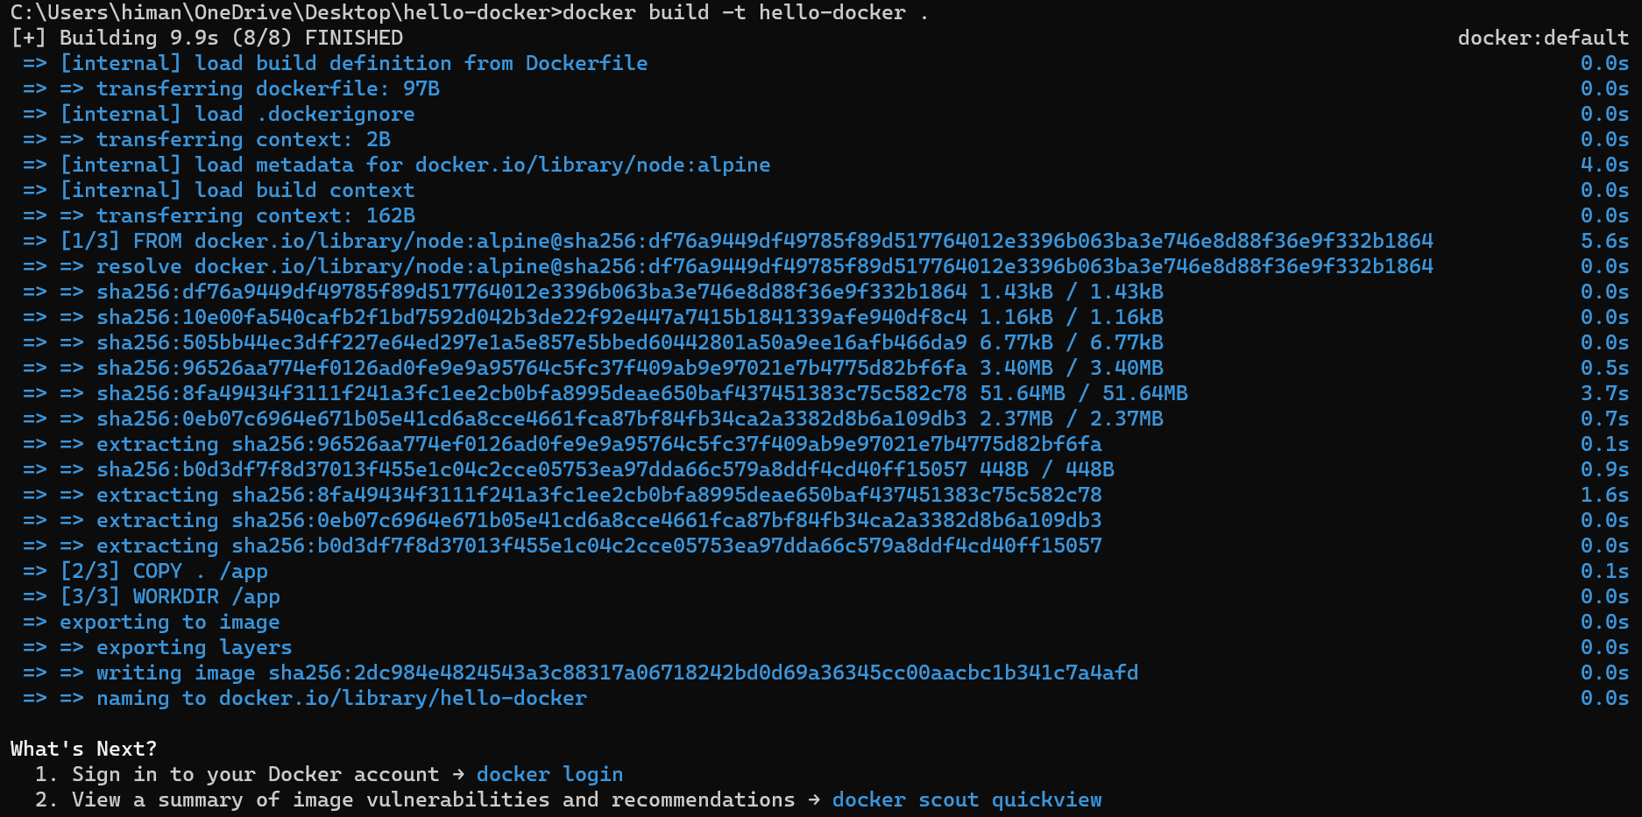

Image is created but not stored in current working directory of our project.

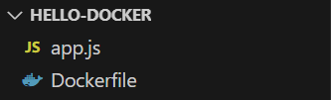🡨 Same as before.

In fact *an image is not a single file*. How docker stores an image is very complex and we do not have to worry about it.

To *see the list of all images on this computer*,

docker image ls

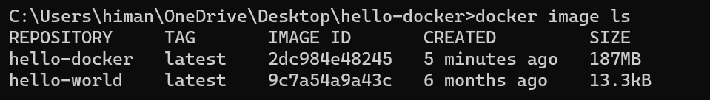

🡪 In this machine we have a repository called hello-docker and in this repository we have an image with tag called ‘*latest*’ (*docker adds it by default*).

*Generally tags are used for versioning our images*, so *each image may contain a different version of our application*.

🡪 Each image has a unique identifier, when it was created and the size of the image. Since we used node from linux alpine we ended up with 187MB of data in this image.

So this image contains alpine linux, node and our application files and the total size is 187MB.

*If we use a different node image that was based on a different distribution of linux, we would end up with a larger image and while deploying that image we would have to transfer that image from one computer to another*. That’s why we used node alpine because this is a very small image.

So we have built this image and now we can run it on any computer running docker using

docker run hello-docker



Now we can publish this image to docker hub so that anyone can use this image then *we can go on another machine like a test or production machine and pull then run this image*.

*On a side note*:

I created a docker hub account

himanshupandey250992

Then docker login command

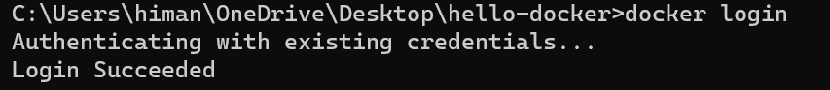

Then I went to docker hub and created a new repository,

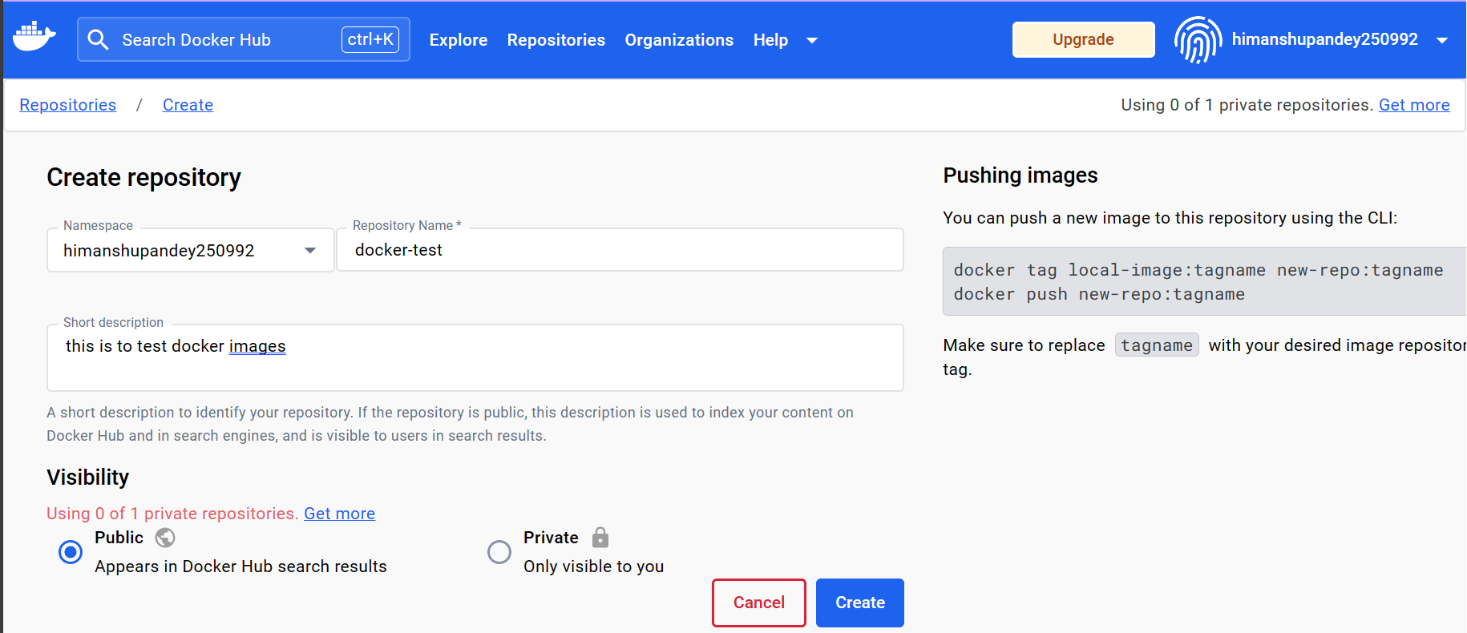

*Continue this lecture*:

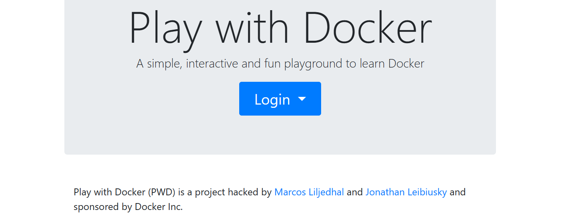

Go to Play with docker site where you can login with docker credentials and start an instance or a virtual machine.

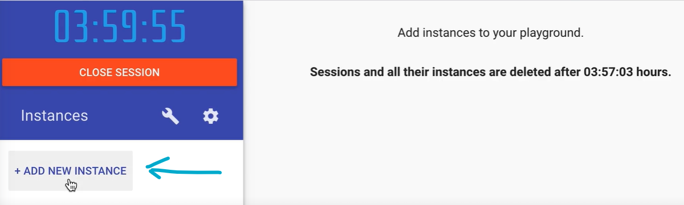

This virtual machine is a blank machine which only has an OS which is linux and docker.

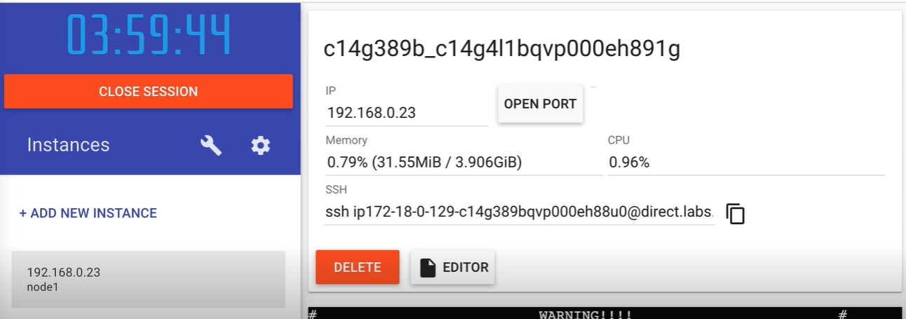

In the terminal window of this virtual machine, we can pull and run the images published in docker hub.

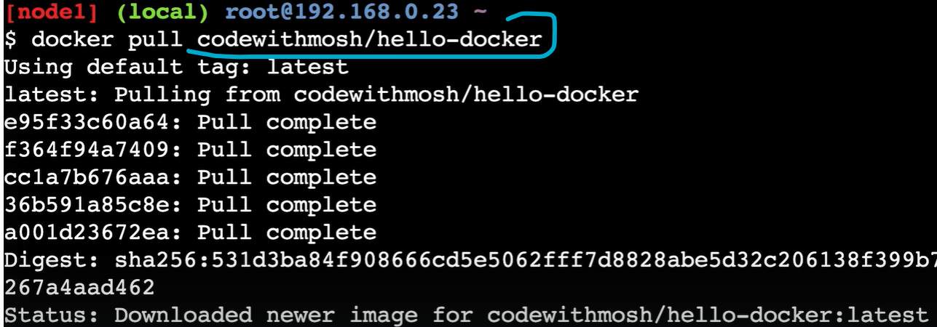

We can verify if the images are downloaded successfully using docker image ls command.

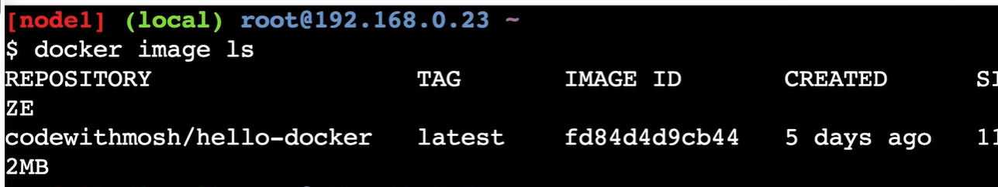

Now we can run this image same way as in development machine using docker run repo-name,

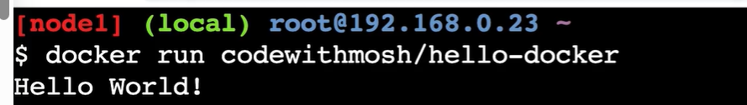

*In summary, we can take any application and dockerize it by adding a Dockerfile to it. This Dockerfile contains instructions for packaging our application into an image. Once we have an image we can run it virtually anywhere on any machine with docker*.